The Weather War
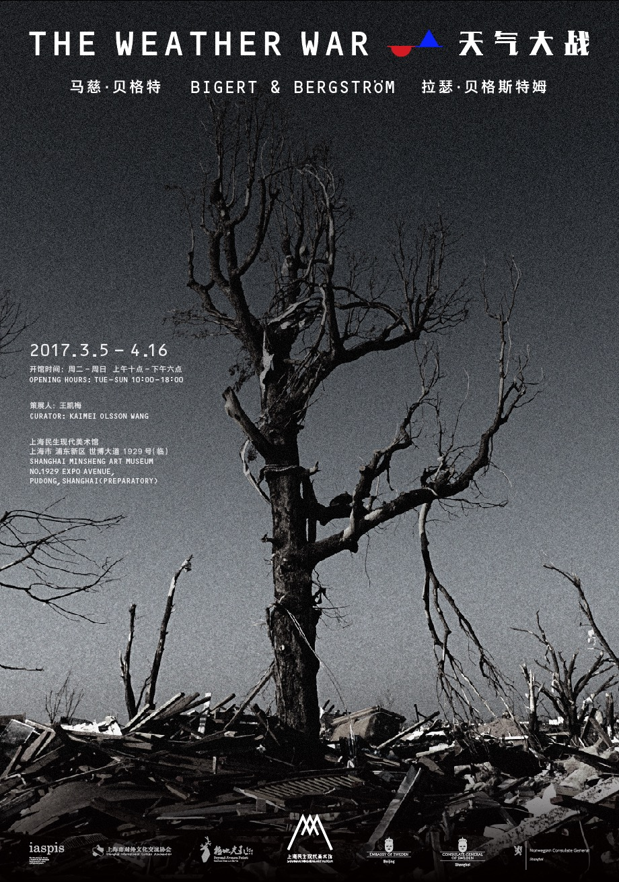
Exihibition：THE WEATHER WAR
Date：5th March-16th April
Address：SHANGHAI MINSHENG ART MUSEUM （No.1929 Expo AVenue,Pudong,Shanghai）

On 4th March, 2017, the Shanghai Minsheng Art Museum will present “The Weather War”, a special commissioned exhibition produced by curator Kaimei Olsson Wang and the Swedish artists duo Bigert & Bergström (Mats Bergart and Lars Bergström, B&B). This will the artistic duo’s first large scale solo exhibition in Asia.

The Weather War is a documentary/art film created by Bigert & Bergström in 2012, depicting B&B’s travel in the American most tornado affected states with their imaginary machine sculputure to stop the tornado. Taking the vantage point from the film, the exhibition shows several of the artistic duo’s most recent climate related art works. Focusing on man’s attempts of atmospheric control through various geo-engineering techniques, the exhibition walks the audience through three different thematic zones: The Storm, The Drought and The Freeze. Finally, the exhibition invites the audience to enter the history of the weather through a new installation entitled Inside the Weather—a Synoptic Battlefield. Total of 30 artworks will use 1500 square meters museum space in two floors.

Bigert & Bergström are the brand name of Sweden’s earth system art. For more then 30 years, they have been working on weather-related art projects. They approach the to the climate issue through scientific researches, historical facts and geo-engineering experiments expressed with their aesthetic imaginations. With films, land art, performance art, installations, sculptures, photography and text, they seek to expand the concept of art beyond the white walls of museums. In the conjunction between art, technology and nature, their artworks cast a humanistic light on scientific research and comment on scientific and social topics discussed in the contemporary society.

The exhibition will be open to the public on the 5th March and will be on display until the 16th April.

Part of work：
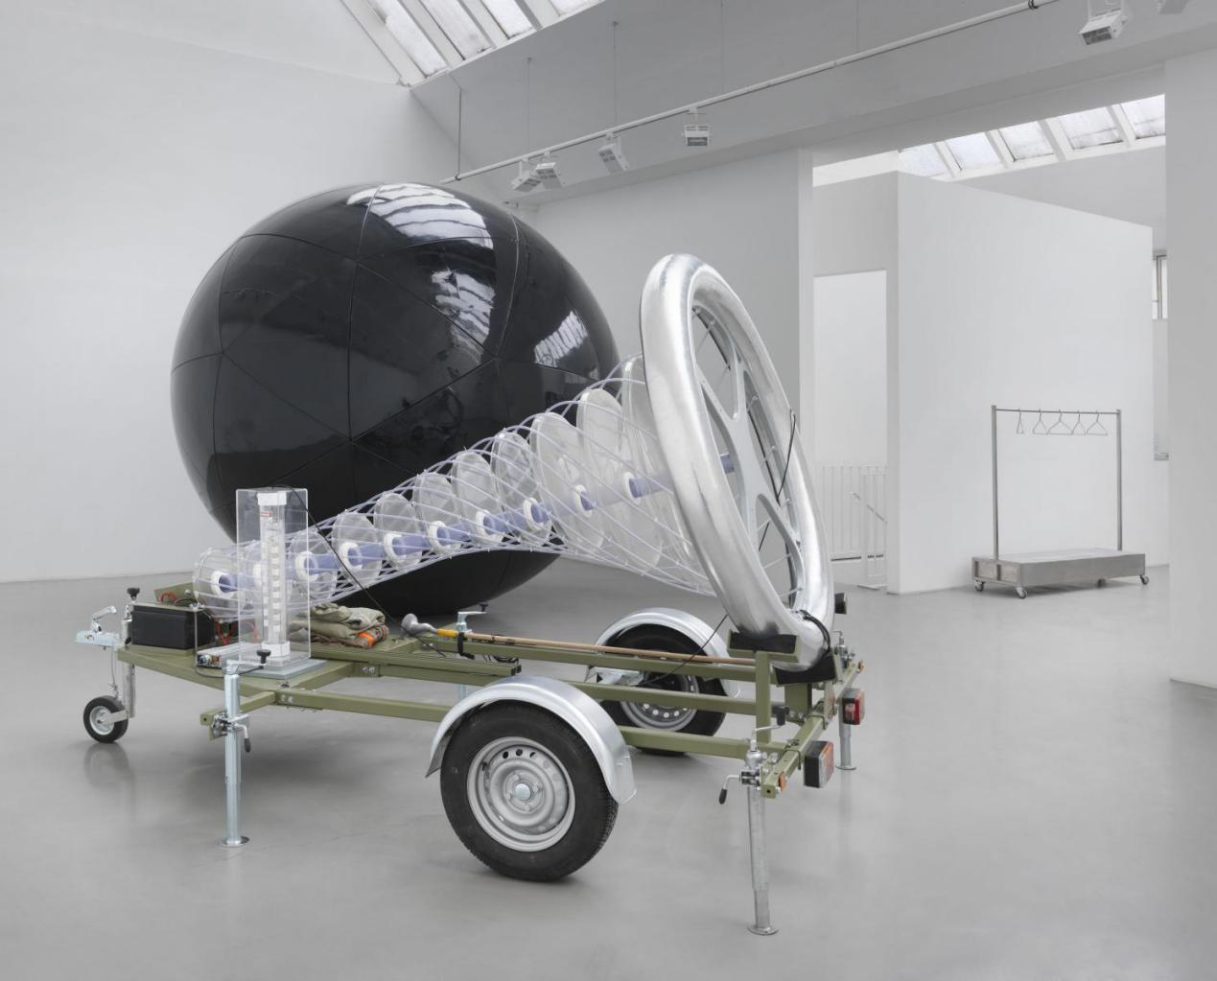
《Tomado Diverter》 installation 2012

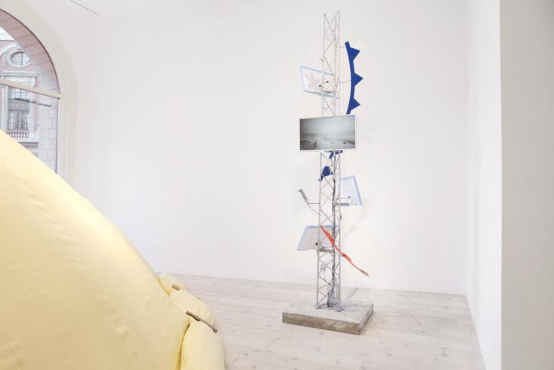
《Rescue Blanket for Kebnekaise》 Video installation 2016

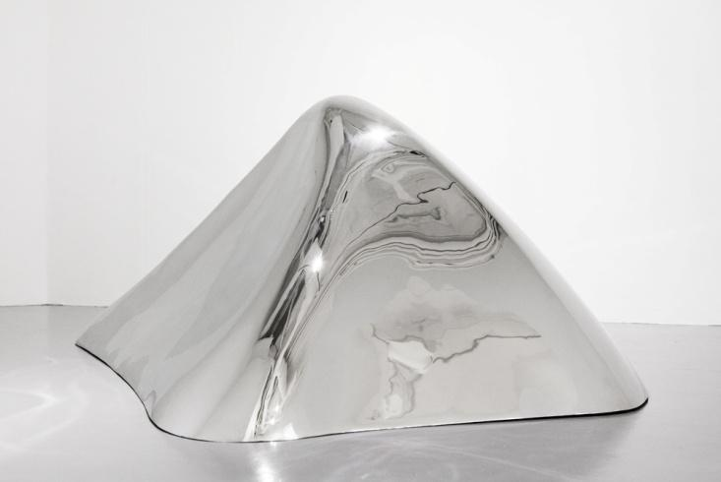
《70cm from not being the highest point in Sweden Kebnekaise》 sculptuer 2016

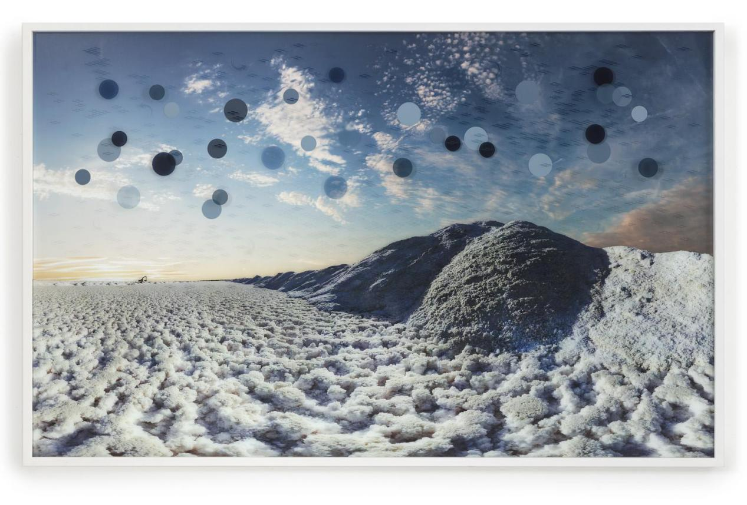
《The Drought》 video installation 2013

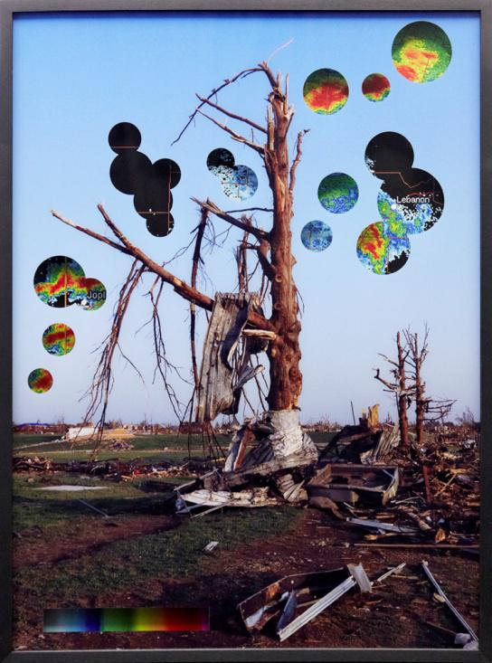
《Disasters of the Weather》 photograph 2012

The Artists ：Mats Bergart Lars Bergström
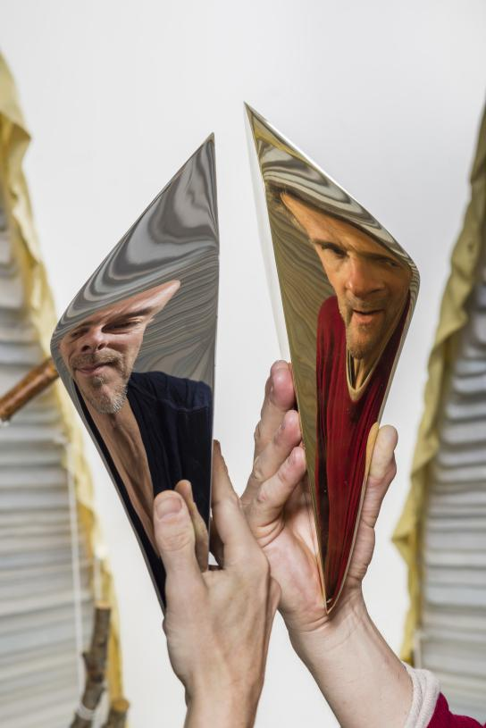
Lars Bergström (b. 1962, Stockholm) and Mats Bigert (b. 1965, Stockholm) have been collaborating since 1986 when they graduated from the Roy Art Academy in Stockholm, Sweden. They are known internationally for their engagement with weather and climate related artworks involving various geo-engineering techniques and atmospheric experiments long before the discussion of Climate Change has become a hot issue in political agenda. The core of their works is placed right in the junction between humanity, nature and technology. With energetic curiosity their art investigate scientific and social topics discussed in the contemporary society. They have participated in numerous exhibitions and biennales around the world. In 1995 they were commissioned by the Swedish government for Expo Swedish pavilion and their films The Weather War won prizes in many international film festivals.

The Curator：Kaimei Olsson Wang
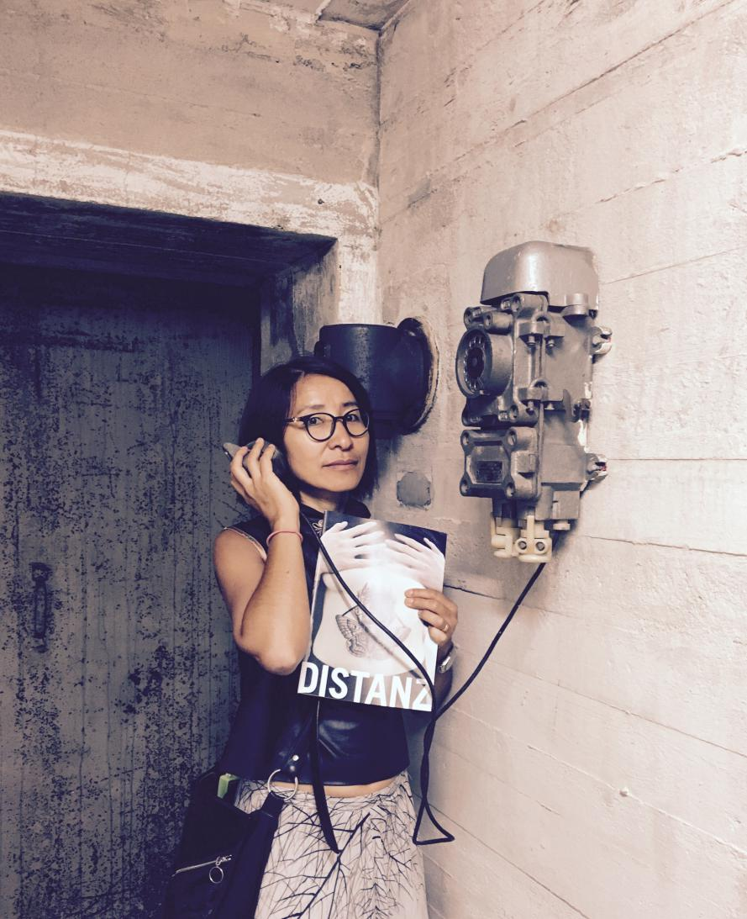
Kaimei Olsson Wang is an independent film and art curator based in Shanghai. She is the founder of the Beyond Frozen Point film festival that has been running its second edition this year. Through her connection with Sweden and deep understanding of the Nordic culture, her curatorial practices extend to many collaborations with Nordic artists and filmmakers. She is also an art writer and contributor for many art magazines in China.

