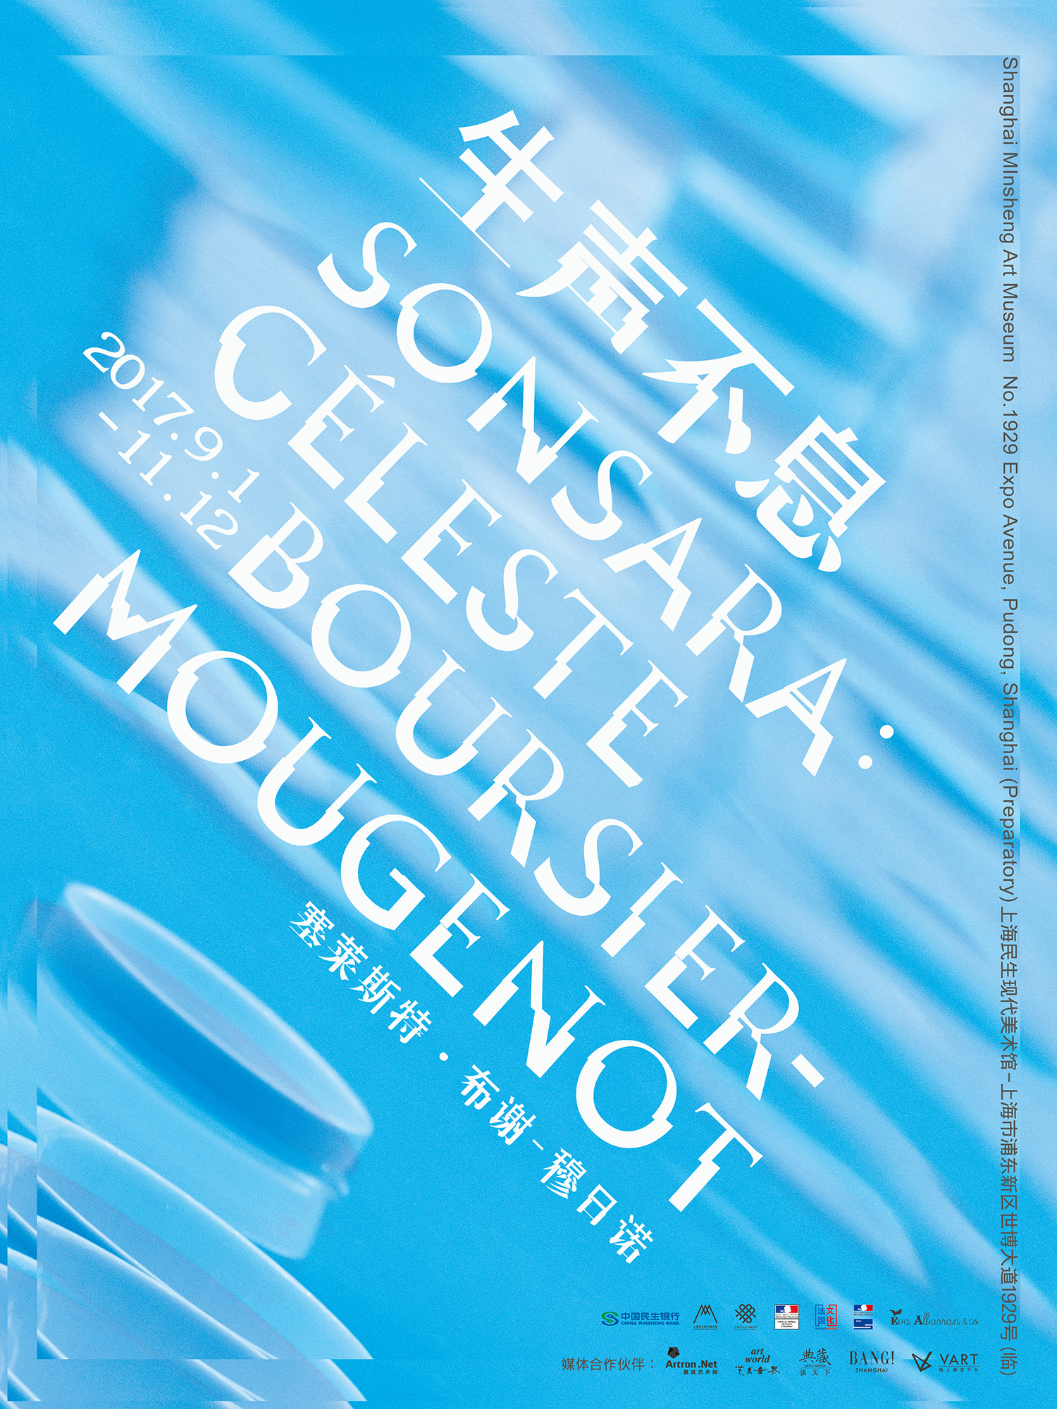SONSARA: Céleste Boursier-Mougenot
Shanghai Minsheng Art Museum
1st September – 12th November 2017
Ticket Fare: 50元（early bird ticket: 30 yuan）

Shanghai Minsheng Art Museum is honoured to introduce the French artist Céleste Boursier-Mougenot’s first solo exhibition in China, SONSARA, which will take place from 1st Septermber to 12th November 2017.

The title of the exhibition, SONSARA, is a combined concept made up of ‘Son’ and ‘Samsara’. Son means sound in French, the auditory effect that can be sensed through the ear. Samsara means the cycle of life. The meaning of this word includes mankind’s past life and the eternal life after death. Every real life is inherited from the past. Thus SONSARA is exactly what the Chinese title is trying to express: It is not only the endless life and continuous sound, but also a metaphor of the spiral exhibition site.

The exhibition, through the artist’s six large sound installation, shows the reflections of two issues, ‘how humans co-exist with the artificial nature’ and ‘building an ecology, imaging the world after human’, which constitute the two sides of the non-zero-sum game between human and non-human beings. Through the cross use and processing of sound, landscape, and moving image, the exhibition will guide the audience into the space where the image and the reality are transformed into each other. It brings impact on the audience in terms of space, physically, and mentally, and then communicates with the streamlined space of the building. The artist wants to examine the music potential of common locations, scenes, or objects in daily life, immersing the consciousness of the audience into the endless charm of those continual and incidental movement and sound. During the exhibition, the audience can come to Shanghai Minsheng Art Museum, to this dynamic and lonely ‘planet’, to together capture the diversity, particularity, and continuity of sound.

Speaking of this exhibition, Ms Gan Zhiyi , director of Shanghai Minsheng Art Museum, said, ‘Boursier-Mougenot provides us with imagination and thinking of the future world. In the meantime, he also emphasizes the importance of effective control and choreography to a great artist, for the works and the audience.’
Some of the artist’s works
clinamen, site-specific art
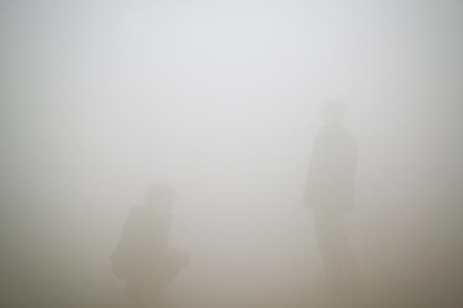
brume, site-specific art
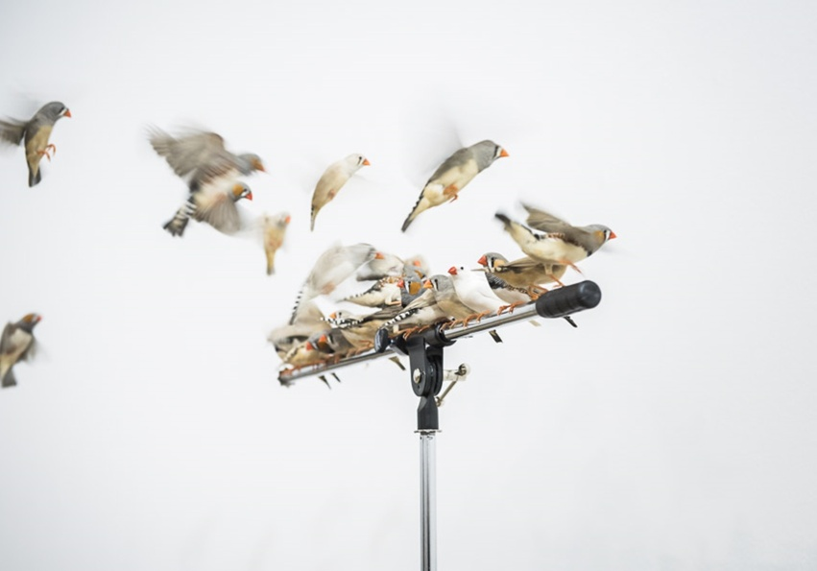
from here to ear, site-specific art

About the artist
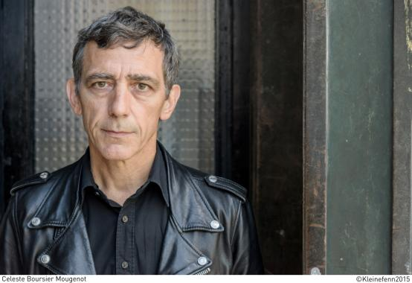
Born in Nice in 1961, Céleste Bousier-Mougenot lives and works in Sète. His works have been widely exhibited and collected all over the world. After training for a musical career at the Conservatoire National de Nice, he worked as the composer of the stage director Pascal Rambert’s “Side One Posthume Théâtre” company for nearly ten years from the 1980s to the 1990s. Bousier-Mougenot started to create sound installation since 1994, was nominated for the Marcel Duchamp Prize in 2010, and represented France at the 56th Venice Biennale in 2015. His exhibition Acquaalta in 2015 turned the space of Palais de Tokyo into a lake and invited the audience to feel all the changes in tactile, visual and auditory experience from this, winning him international recognition. Bousier-Mougenot’s other important exhibitions include San Francisco Museum of Modern Art (2017), Copenhagen Contemporary (2017), Museum of Queensland, Brisbane (2016), Jupiter Artland (2016), Musée des Beaux-Arts de Montréal (2016), French Pavilion at the 56th Venice Biennale (2015), Palais de Tokyo in Paris (2015), Centre Pompidou-Metz (2015), Biennale de Lyon (2017, 2015), Museum of Contemporary Art Tokyo (2012), National Museum of Contemporary Art, Seoul (2011), the Barbican Centre in London (2010) and Le Maison Rouge in Paris (2010).

